The peak loads of MG1, MG2 and MG3 are 1.2+j0.581MVA, 0.8+j0.387MVA and 1+j0.484MVA respectively. The ESS and DG paraments are shown in Table 1 and Table 2. The forecast data of loads and RDG’s output are shown in Fig. 1, with the assumption that the forecast data (per unit) of wind turbine (WT) and photovoltaic (PV) output are the same in each MG. The maximum forecast error of RDG is 25% of its forecast value and obeys the normal distribution whose mean value is 0. The cost of per unit renewable power curtailment and load shedding are 5 CNY/kWh and 200 CNY/kWh. The TOU price of the upper grid is shown in Table 3. The penalty for per unit positive and negative imbalance power are 1.1 and 0.9 times of TOU price. The penalty for voltage violation is 300 CNY/0.01p.u.

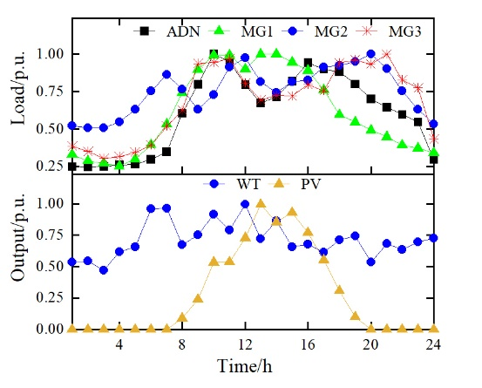

Fig. 1. The forecast load of ADN and MGs as well as the forecast output of WT and PV

Table 1. Parameters of ESSs

|  |  |  |  |  |
| --- | --- | --- | --- | --- |
| Region | /kW | /kWh | /kWh | *η*/% |
| MG1 | 200 | 1000 | 0 | 93 |
| MG2 | 250 | 1500 | 0 | 93 |

Table 2. Parameters of DGs

|  |  |  |  |  |  |  |  |
| --- | --- | --- | --- | --- | --- | --- | --- |
| Region | DG | *Pg*,min/kW | *Pg*,max/kW | *ag*/(CNY/kW2) | *bg*/(CNY/kW) | /(CNY/kW) | *rg*,max/kW |
| ADN | CDG1 | 150 | 600 | 0.0005 | 0.50 | 0.60 | 350 |
| CDG2 | 80 | 700 | 0.0010 | 0.20 | 0.60 | 400 |
| CDG3 | 100 | 800 | 0.0008 | 0.60 | 0.60 | 500 |
| MG1 | WT | 0 | 500 | \ | \ | \ | \ |
| PV | 0 | 400 | \ | \ | \ | \ |
| CDG1 | 50 | 400 | 0.001 | 0.30 | 0.70 | 400 |
| MG2 | PV | 0 | 500 | \ | \ | \ | \ |
| WT | 0 | 200 | \ | \ | \ | \ |
| MG3 | WT | 0 | 400 | \ | \ | \ | \ |
| CDG1 | 30 | 300 | 0.0015 | 0.30 | 0.40 | 300 |
| CDG2 | 0 | 400 | 0.0020 | 0.40 | 0.50 | 400 |

Table 3. Day-ahead TOU price of upper grid

|  |  |  |
| --- | --- | --- |
| Periods | Time Range | Price/(¥/kWh) |
| Peak | 10:00-15:00, 18:00-21:00 | 1.322 |
| Flat | 7:00-10:00, 15:00-18:00, 21:00-23:00 | 0.832 |
| Valley | 23:00-7:00 | 0.369 |